1. Display the grid items with a padding value of 20px using the selector (grid-items)

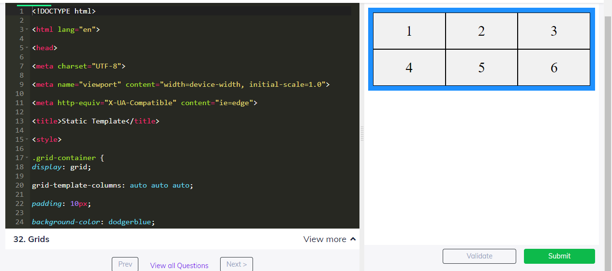

2. Transform the text 'Self Learning is the best learning forever' to upper case and display it.

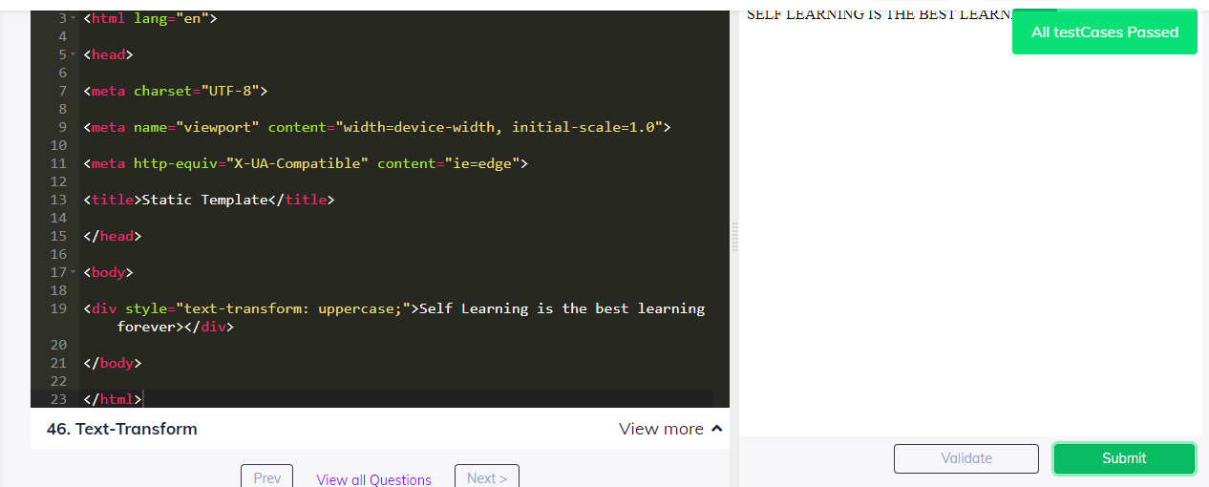

3. Edit the given anchor tag to make the link open on new tab using HTML

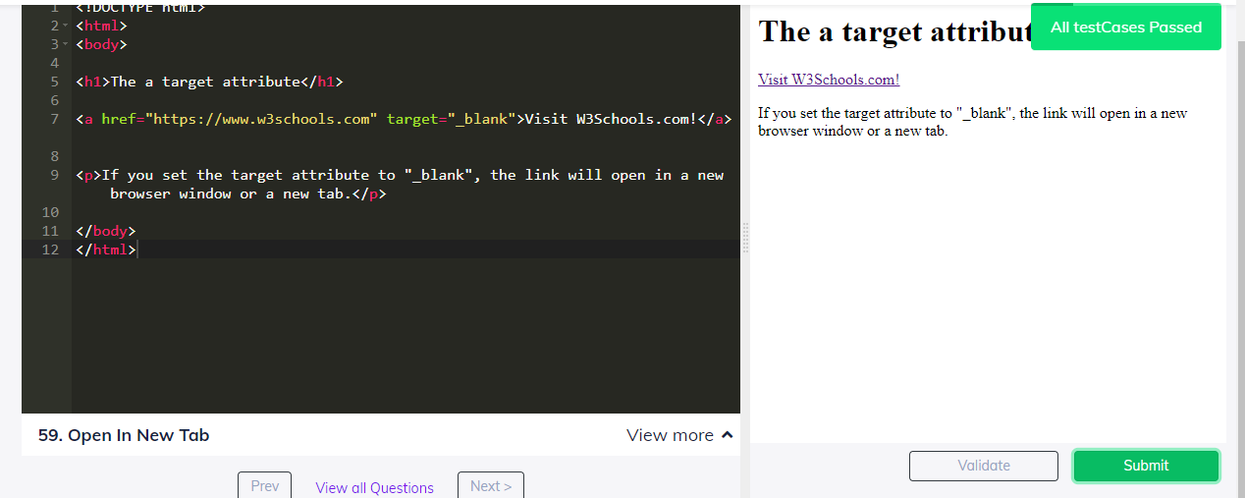

4. Display "This is a italic paragraph" in a italic tag using HTML

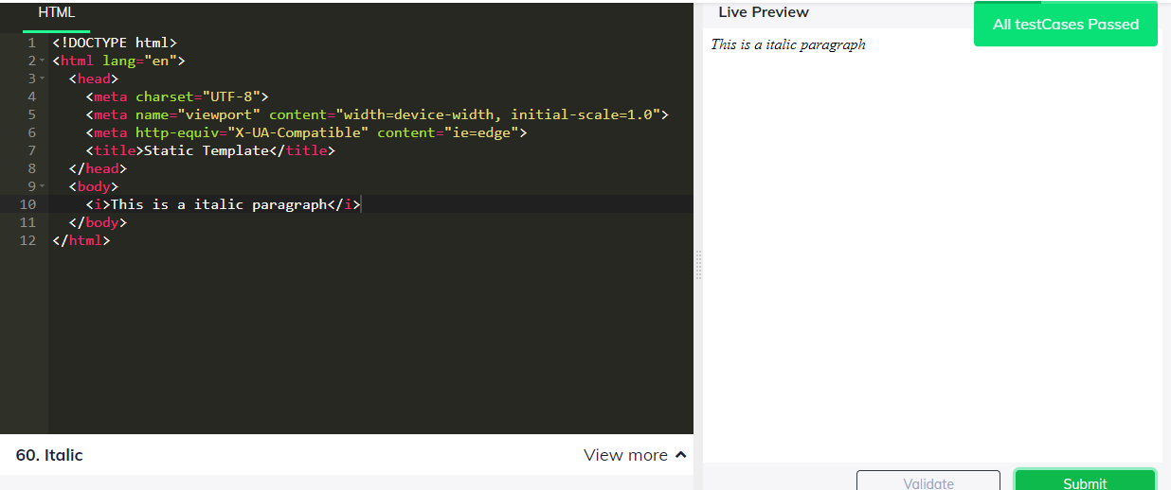

5. Display "This is a underlined paragraph" with an underline using HTML

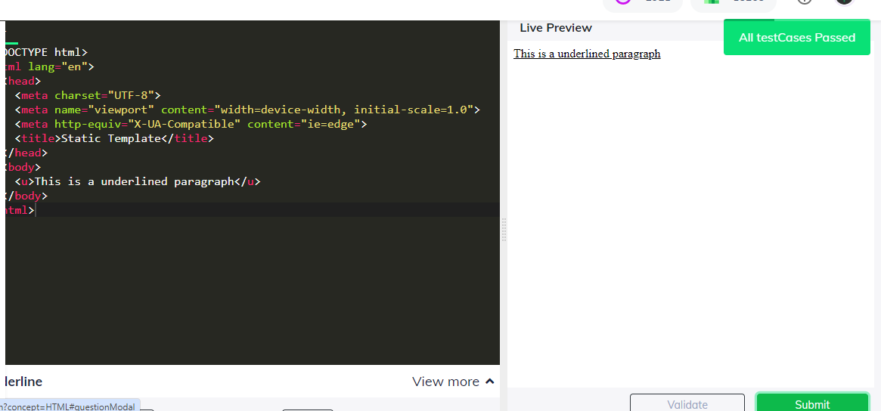

6. Display a Button showing "Click Me" using HTML

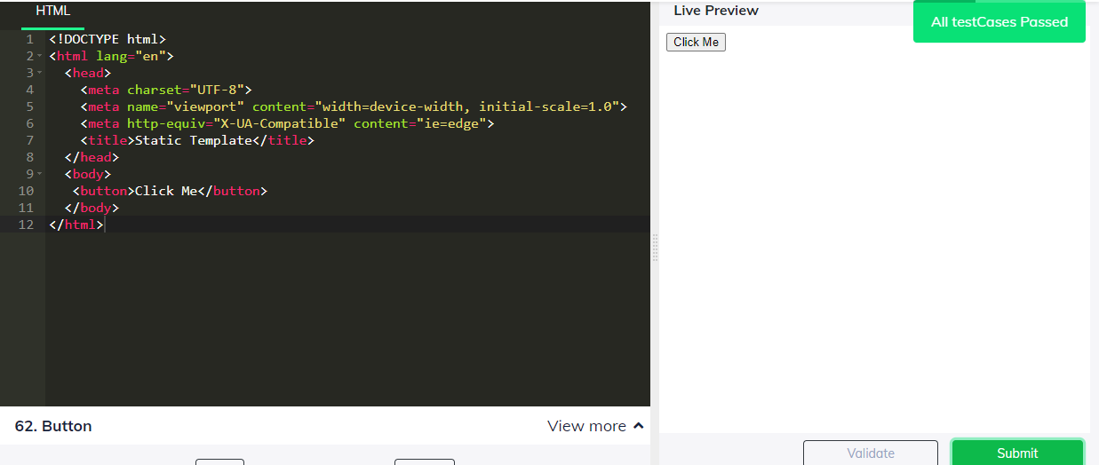

7. Display "Hello from guvian" with 😀 emojis front and back in a h1 tag

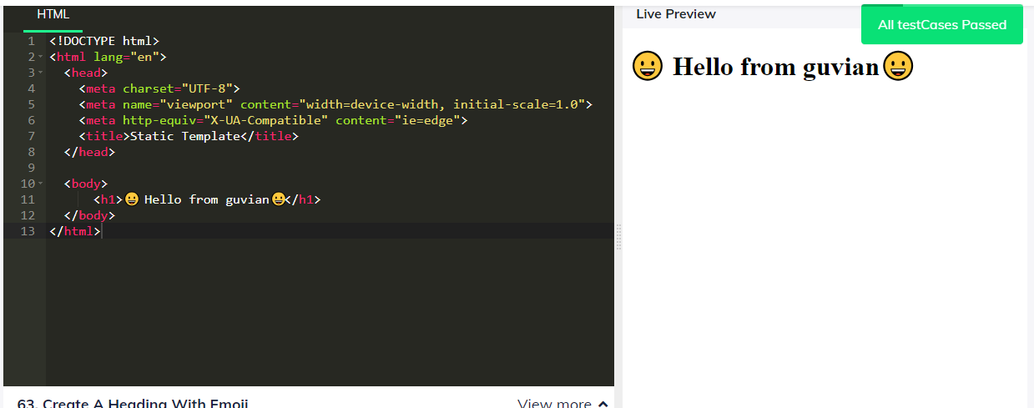

8. Display "Hello from Guvian" in red colour, aligned center using CSS selector in paragraph tag

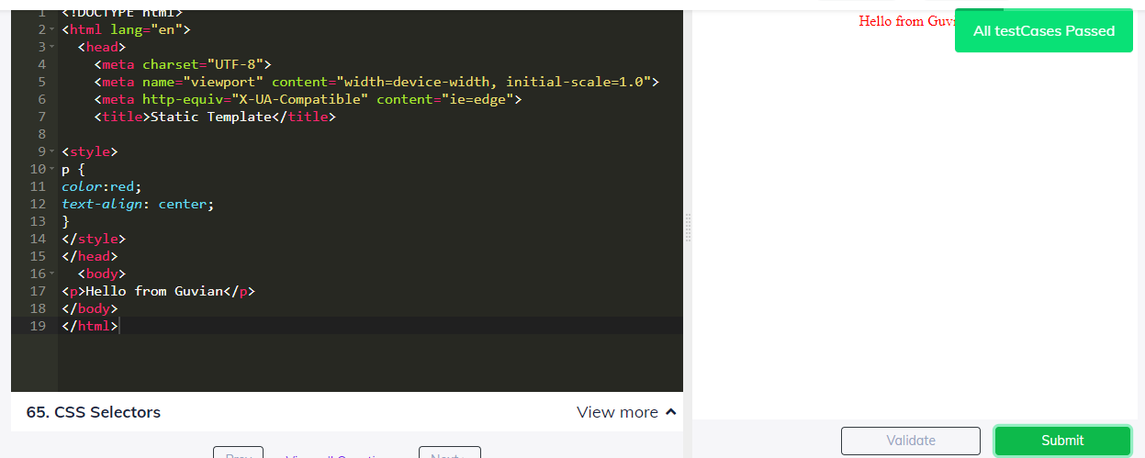

9. Display "Hello from Guvian" in a margin of 20px with pink background in a paragraph tag

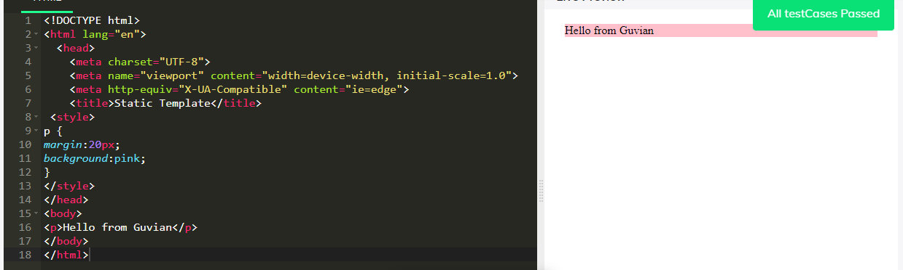

10. Display an statement "Hello From Guvian!" in a h1 tag and underline it using CSS

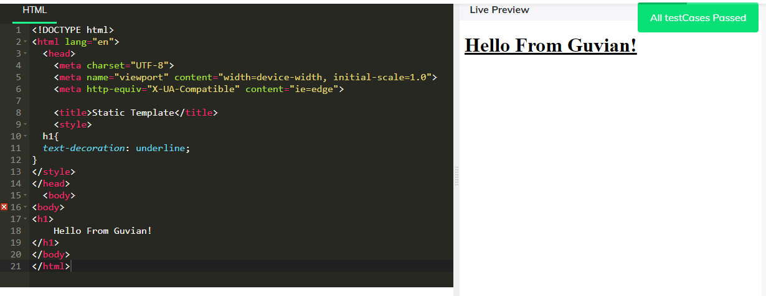

11. Display "Hello from guvian" using padding on all four sides, 10px, with light blue background in a paragraph tag.

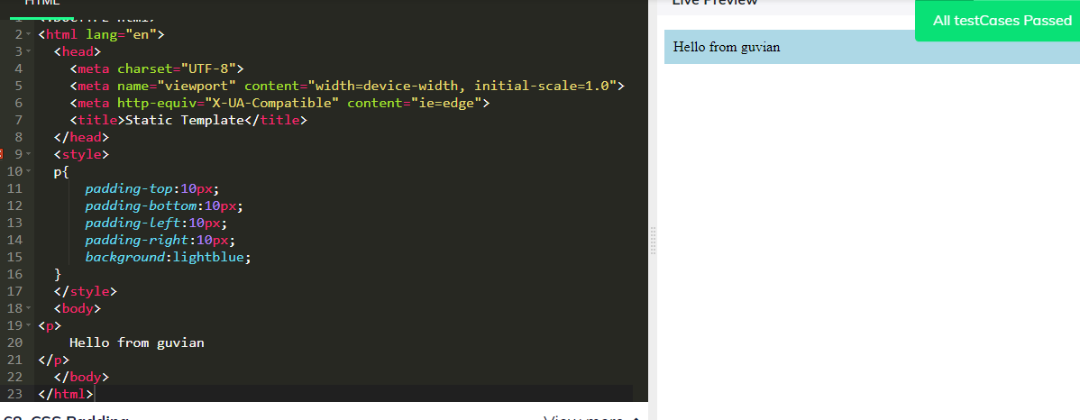

12. Create a Unordered list with a id "unorderList" and the elements (HTML, CSS, Javascript) in HTML.

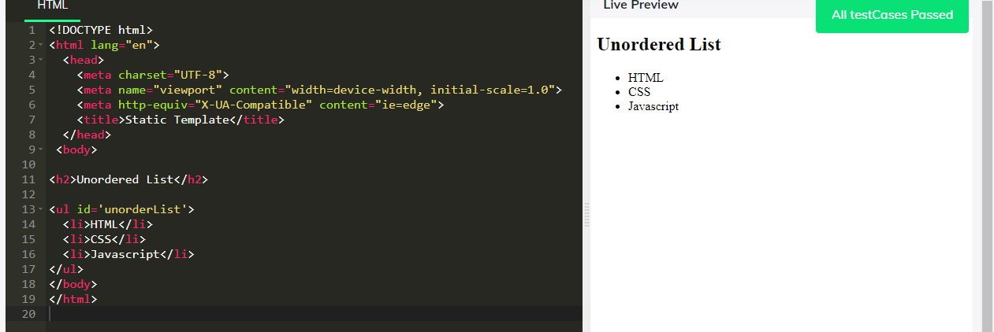

13. Create a ordered list with a id "orderedList" and the elements (HTML, CSS, Javascript) in HTML.

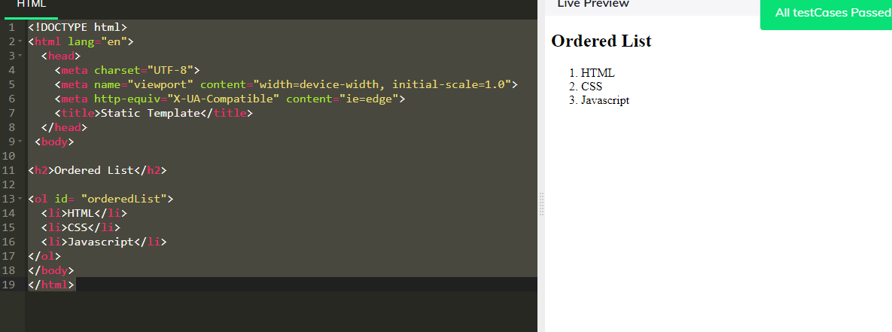

14. Form a checkbox with options as I am an extrovert, I am an introvert, I am polite

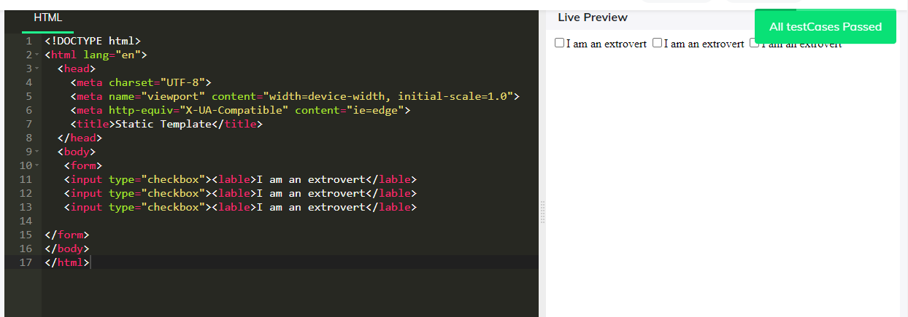

15. Form radio buttons with values Male, Female, Other

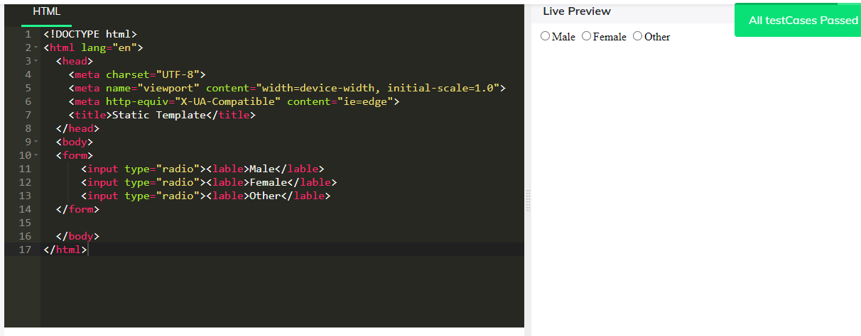

16. Create an iframe of width 300 and height 200 using iframe tag in html

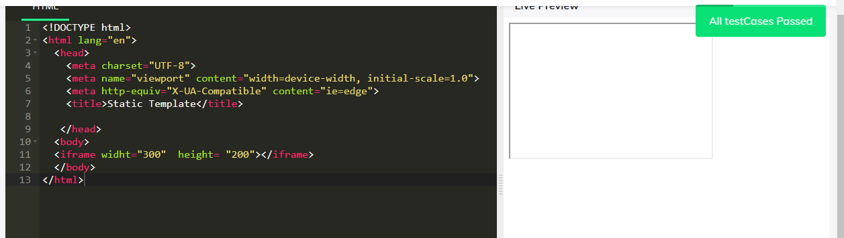

17. Form a SVG stroke of width 600, height 80 of pink color

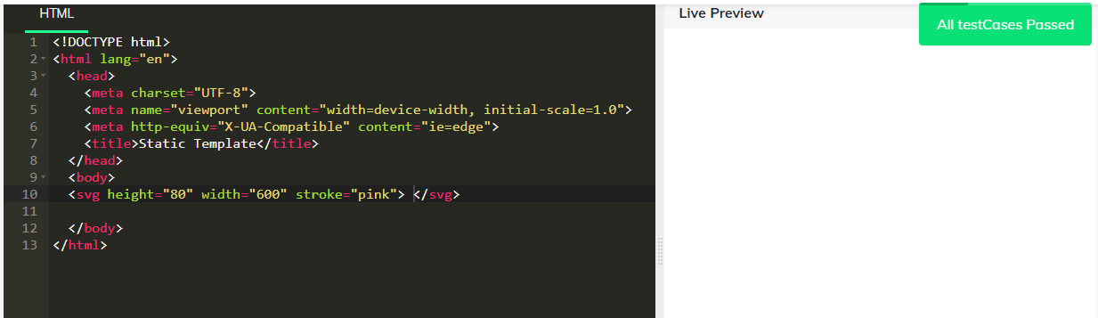

18. Display a link to 'www.google.com' with "Google" as text using HTML

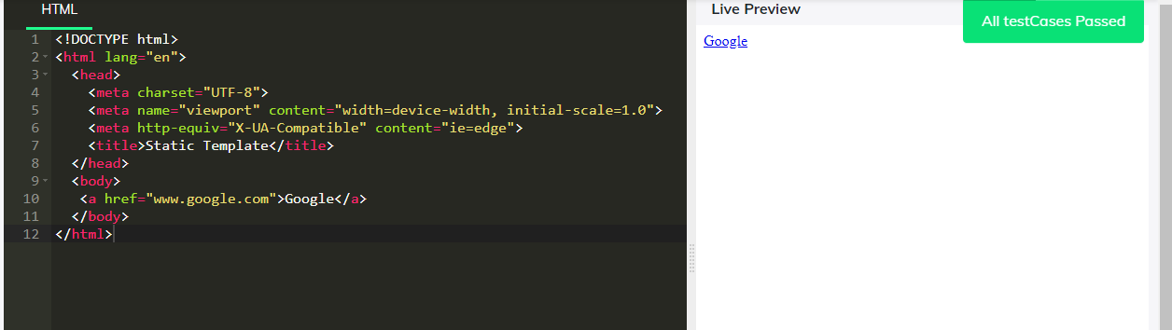

19. Display "Hello from Guvian" in a paragraph tag, where you have to increase the font size of the word 'Guvian' using class named 'note' to 20px in a span tag

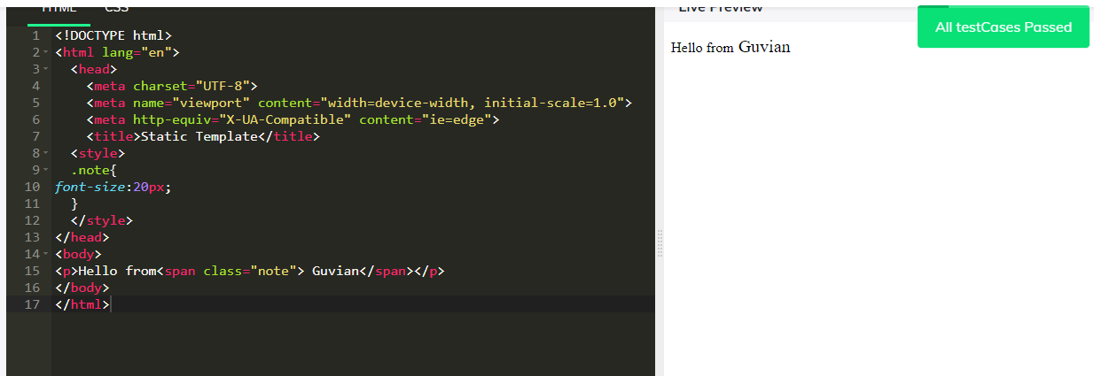

20. Assign "Hello" to a string variable, 1 to a variable, print both in same line using Java Script

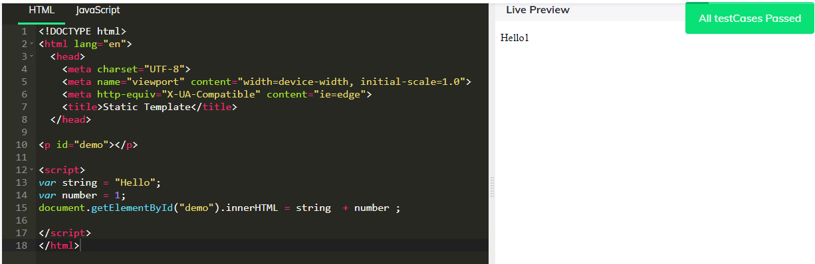

21. Display "Hello From Guvian" using paragraph tag and by using :after pseudo element add ! after the text

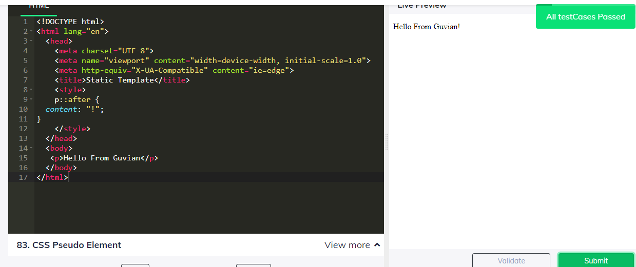

22. Create a input field with a label "Enter the name"

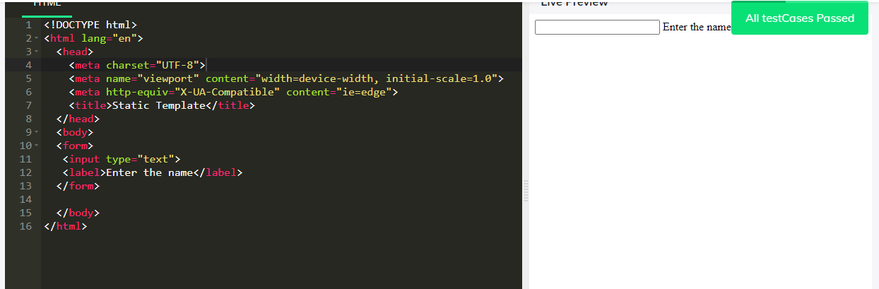

23. Display "Hello From Guvian" in a paragraph and highlight the word "Hello" in italics using internal CSS via class name italic

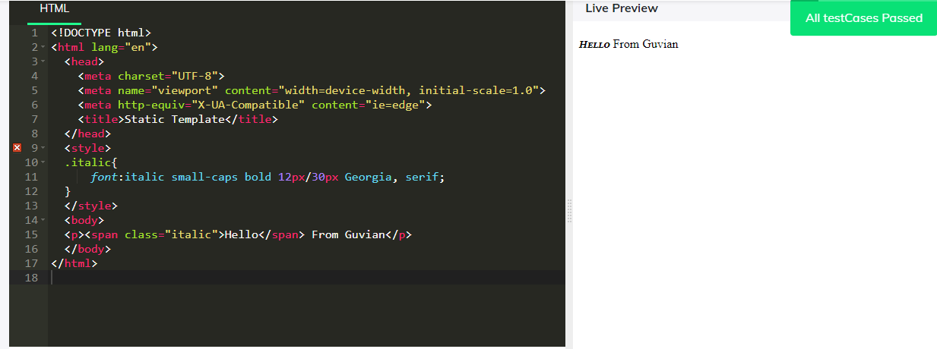

24. Create a HTML form, With "FirstName" , "LastName" as id to input fields, with a "submit" button and a Heading tag "Guvi Form"

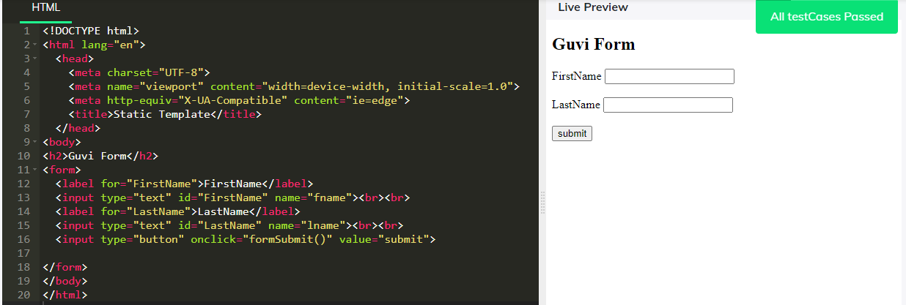

25. Create a HTML form, With "Firstname", "Password" as id for input fields, with a "submit" button and a Heading tag "Guvi Form", Password field should get only 4 characters as input

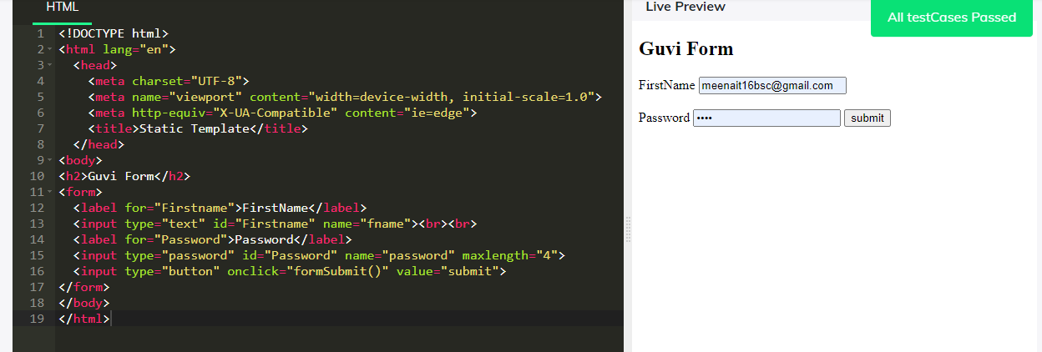

26. Include a image with id 'myImage' where the source is 'https://www.guvi.in/images/guvi-logo.png'

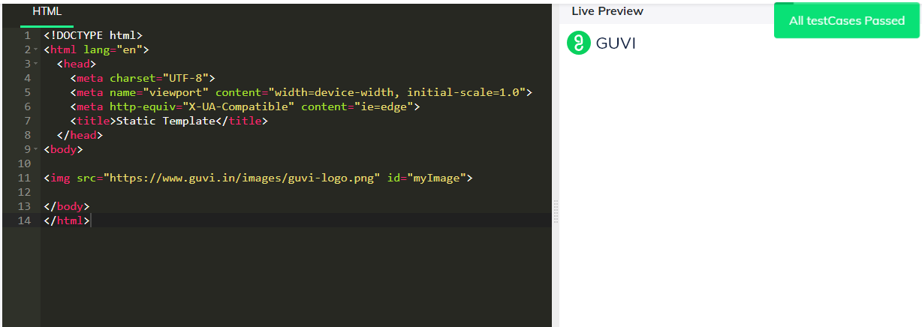

27. Draw a Circle with radius of 40 with blue colour, black colour stroke using SVG (Width =100 and height =100) x,y 50,50

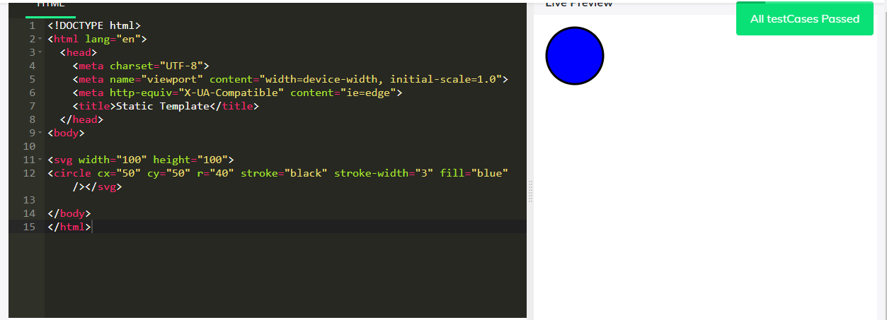

28. Draw HTML canvas, cavas details, width="200" height="100" style is border:1px and solid #d3d3d3

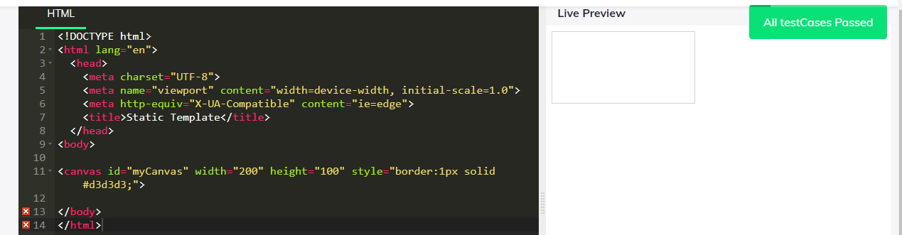

29. Display a rectangle using canvas of width 200 and height 100 with border color as black using id selector

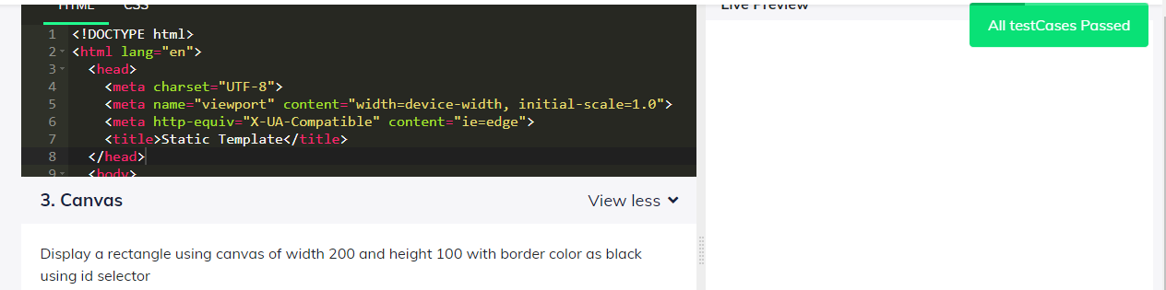

30. Given a array, sort the array in Ascending order and print, using Javascript array=[40, 100, 1, 5, 25, 10]; Example(array=[5,4,3,2,1] sorted array 1,2,3,4,5 in p tag)

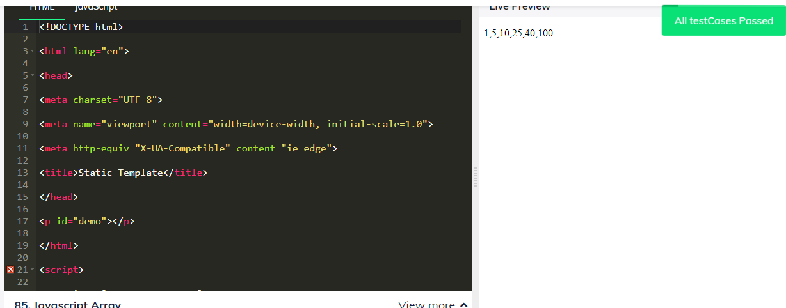

31. Set the property flex-wrap to nowrap using class selector(.flex-container)

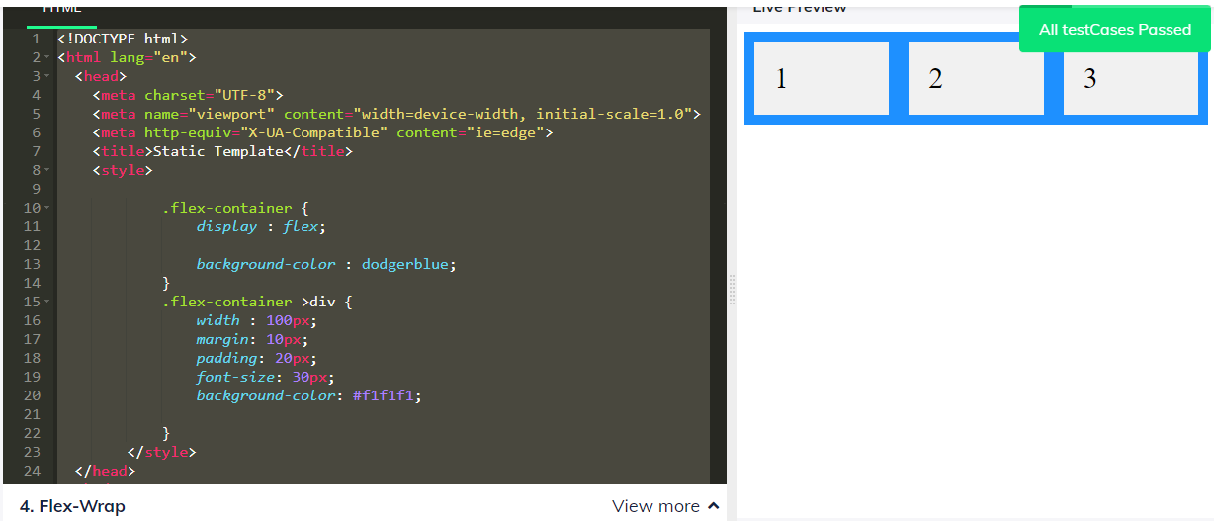

32. change the background color of the grid items using the (.grid-container) to dodger blue

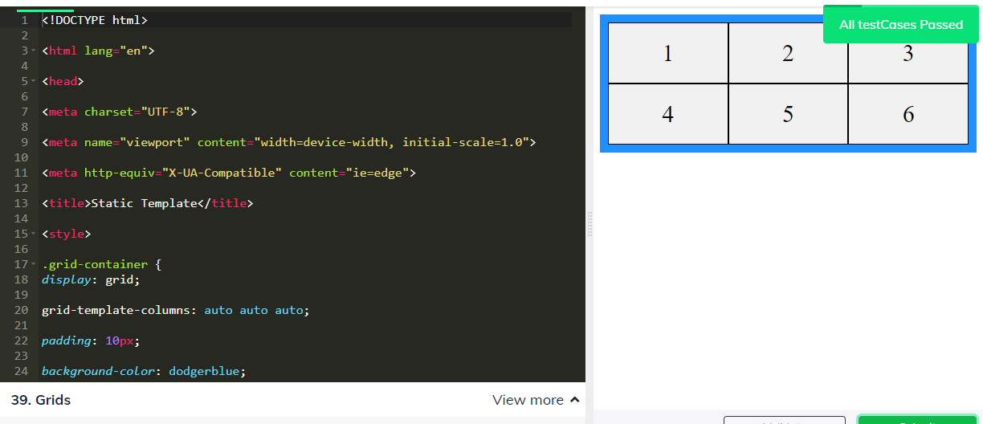

33. Display a grid-container with the padding of 10px using the grid-container selector

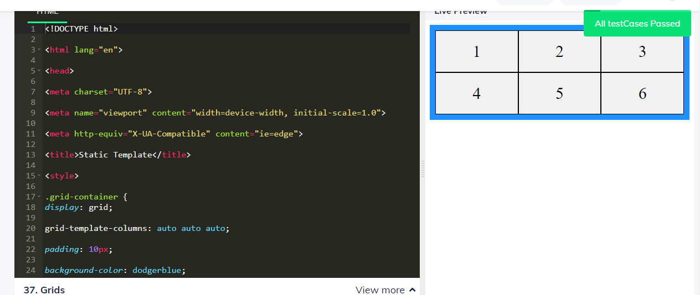

34. Give a circular radial gradient in which red at center and then yellow and last green inside the displayed shape using CSS

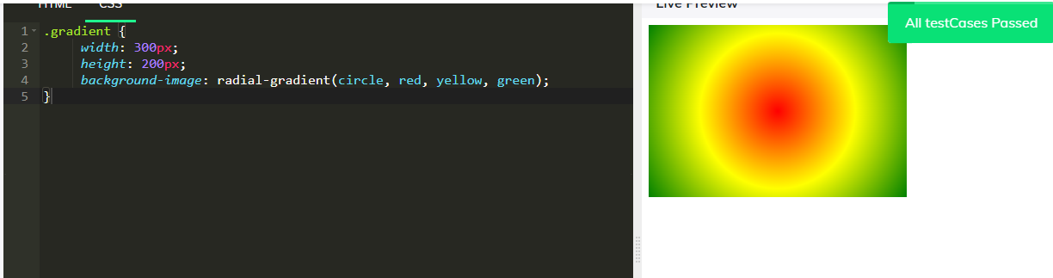

35. Give a linear gradient of red to yellow from bottom-left to top-right inside the displayed shape using CSS(using degrees for direction change)

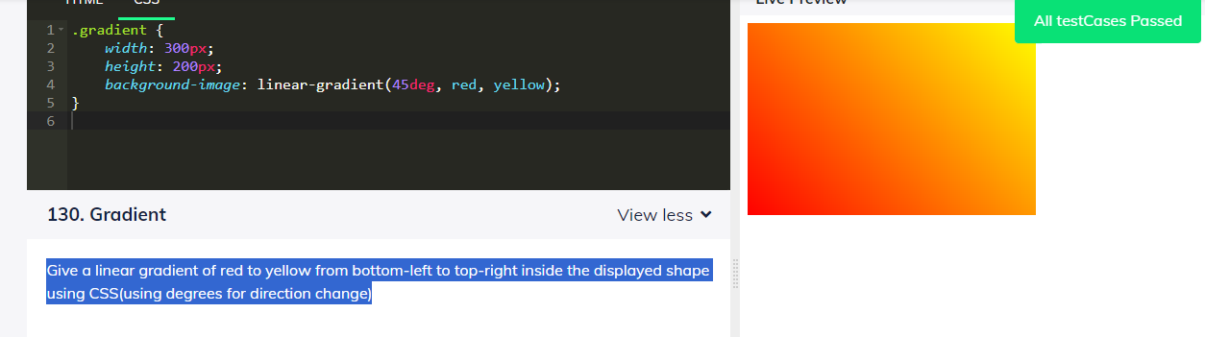

36. Give a linear gradient of red to yellow from bottom-right to top-left inside the displayed shape using CSS( use degrees for direction change)

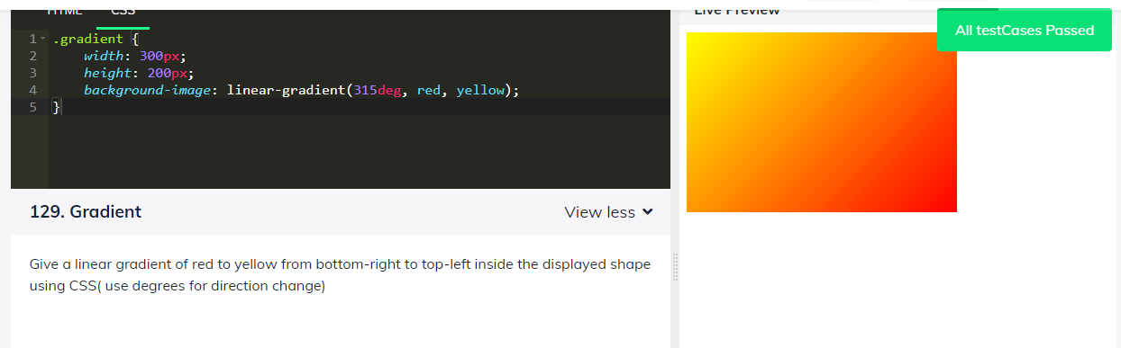

37. Give a linear gradient of red to yellow from top-right to bottom-left inside the displayed shape using CSS( use degrees for direction change)

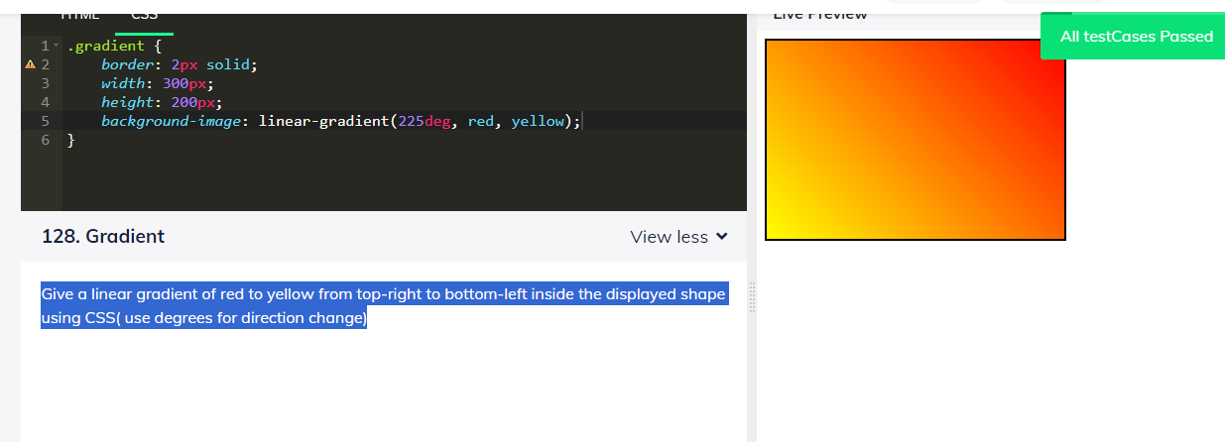

38. Give a linear gradient of red to yellow from top-left to bottom-right inside the displayed shape using CSS( use degrees for direction change)

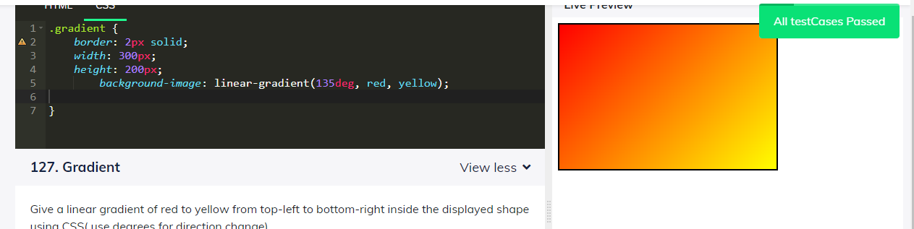

39. Give a linear gradient of red to yellow from right to left inside the displayed shape using CSS( use degrees for direction change)

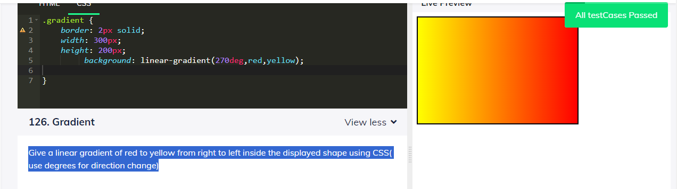

40. Give a linear gradient of red to yellow from bottom to top inside the displayed shape using CSS(use degrees for direction change)

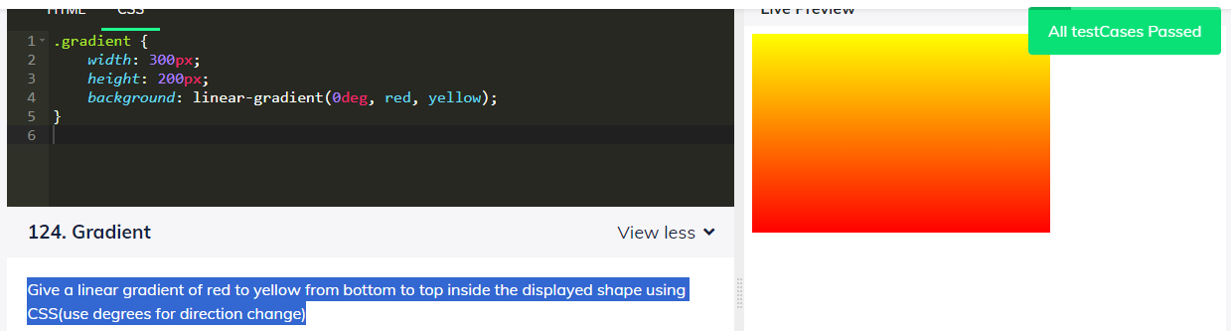

41. Give a linear gradient of red to yellow from top to bottom inside the displayed shape using CSS

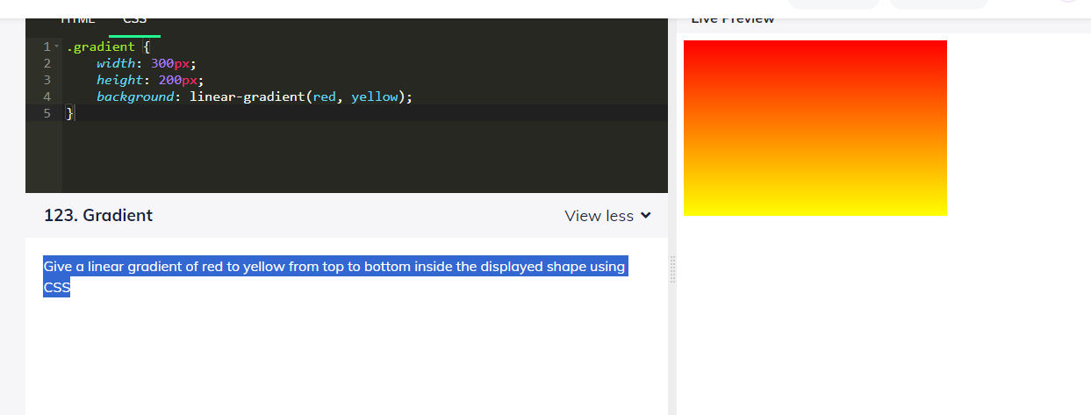

42. Display "Hello From Guvian" using paragraph tag and by using :after pseudo element add ! after the text

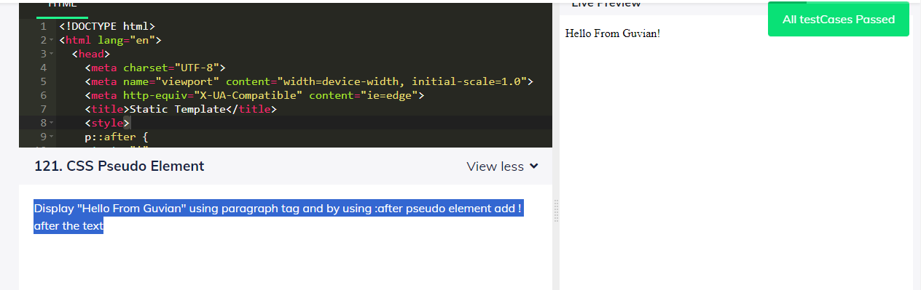

43. Display "Hello from Guvian" in a paragraph tag, where you have to increase the font size of the word 'Guvian' using class named 'note' to 20px in a span tag

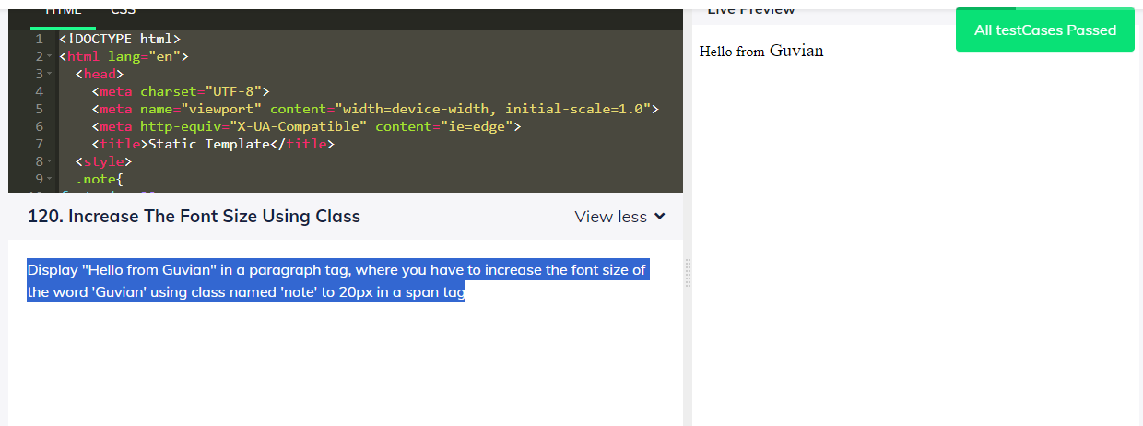

44. Change the color of the text "This is an Umbrella" to blue color by using javascript

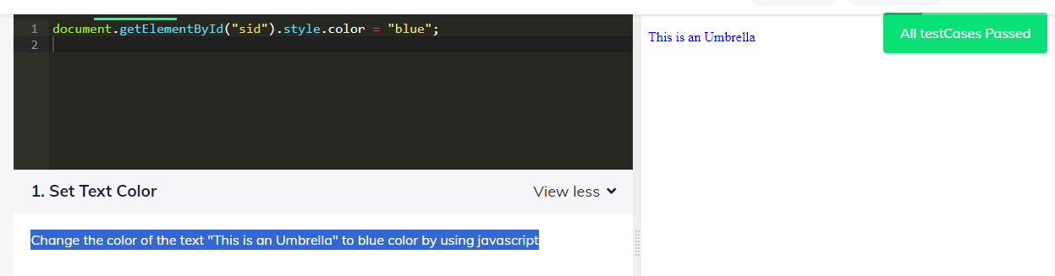

45. Display the length of input field value with id 'myLength' in paragraph tag with id 'sid' using JS. Note: Values are assigned dynamically during validation.

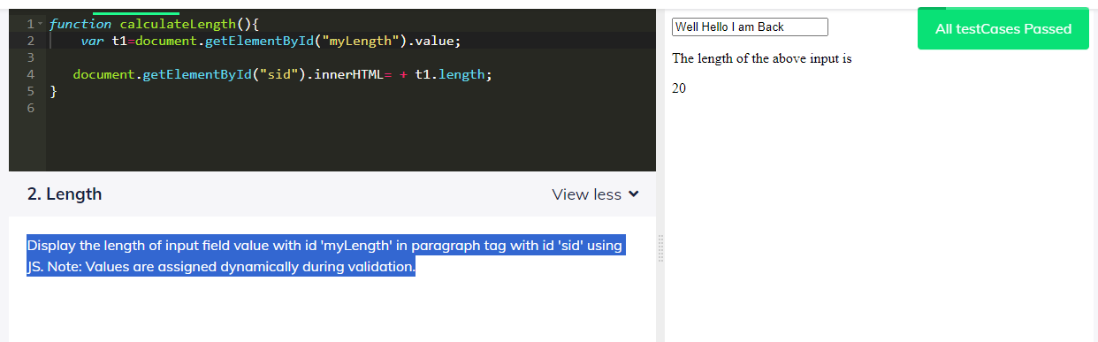

46. Add values in Input 1 and input 2 fields with id 'in1', 'in2' and Display the resultant in the paragraph tag with id "result" Note: Values are assigned dynamically for evaluation

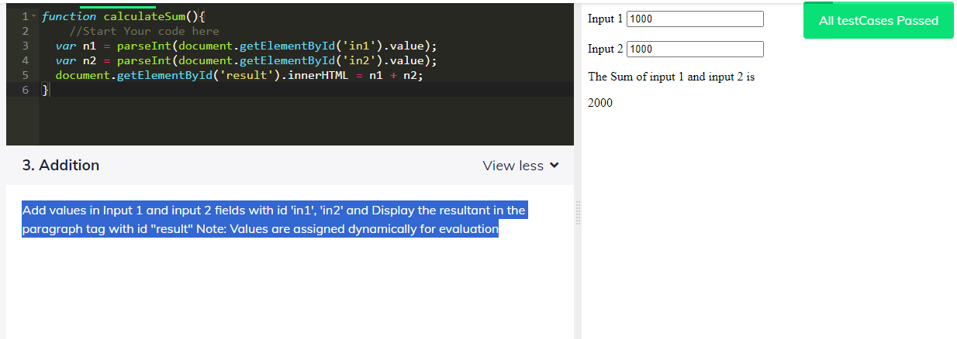

47. Change the content of the paragraph tag with id name as hello from "Hello by HTML" to "Hello by JavaScript"

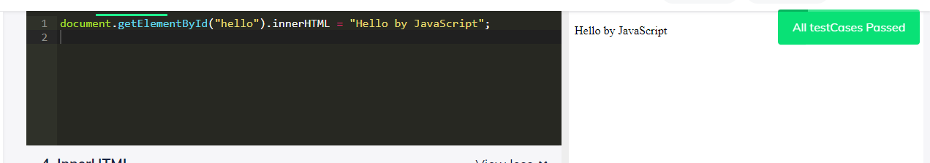

48. Hide the elements with id name as hello from "Hello by HTML" using JavaScript with display property

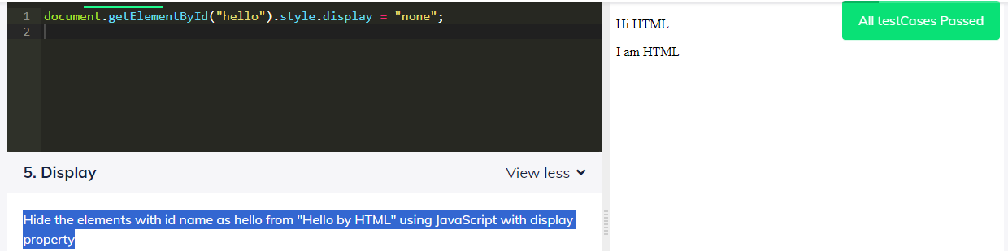

49. Display "Hello World!" by using a p tag which is already present with id 'demo' in JavaScript

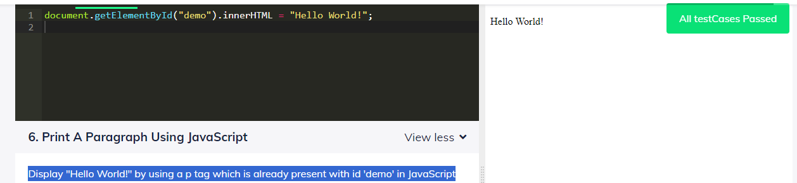

50. Display the value of selected option in paragraph tag with id 'selectedOption' using Javascript. Note: Values are changed dynamically for evaluation

